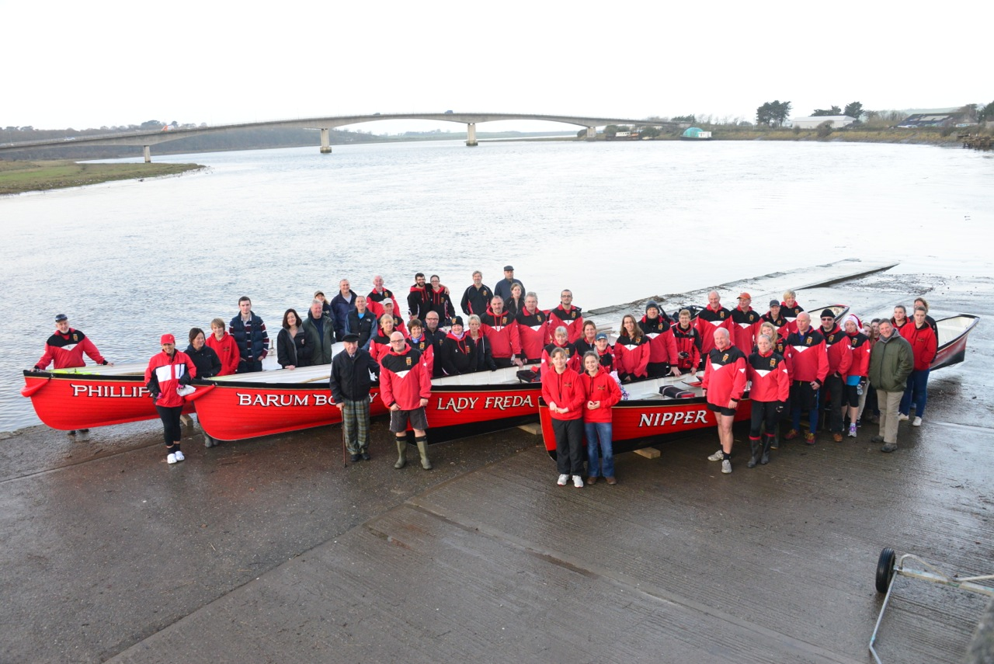

Barnstaple Pilot Gig Club CIO 3 Year Strategy and Plan

This Strategy and Plan describes the proposed development of the Club over the next 3 years.

Published 14th July 2017

VERSION HISTORY

Version | Date Issued | Brief Summary of Change | Owner’s Name
Initial draft for comment | 1st July 2017 | First Draft | Kevin Ward
0.1 | 7th July 2017 | Committee comments | Kevin Ward
1.0 | 14th July 2017 | Adopted and issued | Kevin Ward

For more information on the status of this document, contact: | Kevin Ward
Date of Issue | 14th July 2017
Reference | kw/business plan/2017

CONTENTS
VERSION HISTORY 2
1. Purpose 4
2. Background 4
Charitable Incorporated Organisation 4
Where are we now 5
3. Aspirations and Goals…………………………………………………………….….6
4. Conclusion 7
5. Recommendations and Plan 2
6. Glossary 2
7. References 2
8. Associated documents 2

Purpose
  - The purpose of this document is to set out Barnstaple Pilot Gig Club’s (BGPC) 3 year strategy and plan. The plan and strategy is available to be presented to aid introduction for application for funding, or grant applications to enable BGPC to continue progression as a fully inclusive club. In doing so providing provision for the community of Barnstaple and its surrounding areas so that all people of 11 years of age and over can enjoy the growing sport of Pilot Gig Rowing. This document also sets out the aspirations and goals of the membership of BGPC.

Background
  - BPGC was founded in January 2010 by a small group of keen gig rowers who felt it was about time Barnstaple had its own pilot gig club in this growing traditional sport. From 2010 to the present, progression has been made to establish BPGC within the Gig rowing fraternity and the town of Barnstaple North Devon. BPGC has been fortunate and has also worked hard within the community to publicise the club and secure funding either by grant application, fundraising and having a benefactor that has enabled the annual membership of approximately 100 including its junior section to enjoy the sport of Pilot Gig Rowing. The club participates in competitive rowing regattas within the British Isles and maintains an annual presence at the World Pilot Gig Championships held on the Isles of Scilly. The club has also attended events such as the Great London River Race and is often seen present at local events as Pilton Green Man Festival, Barnstaple Carnival, The North Devon Show and provides sea escort services for North Devon Hospices ‘Floating Bye’. The club holds an annual regatta on the river Taw each year which attracts other gig rowing clubs and spectators to the town of Barnstaple.

Charitable incorporated Organisation (CIO) Status.
  - On 1st June 2017 BPGC became a CIO. The size of the club, its presence in the local community in Barnstaple and the gig rowing fraternity, the varied age range of membership and the amount of equipment (assets) the club has acquired influenced a decision that it should apply for some sort of affiliated status. The governing body for gig rowing, The Cornish Pilot Gig Association (CPGA) had recently applied to for and was granted CIO status and encouraged pilot gig clubs to do the same or similar to offer protection to its members, committee and the assets held by individual clubs.
  - As a CIO the club has voted in 6 Trustees and a committee of 11, this is made up of:
- Chairman (Trustee)
- Vice Chairman (Trustee)
- Secretary (Trustee)
- Treasurer (Trustee)
- Welfare Officer (Trustee)
- Health and Safety Officer (Trustee)
- Membership Secretary
- Junior Section Co-ordinator
- Maintenance Officer
- Training Co-ordinator (Bosun)
- Events Officer (incorporating fund raising)
Positions are also held by members in the club who may also be part of the committee as crew organisers, crew selectors for regattas, press liaison, 100 club organiser and procurement.

Where are we now
  - At conception of the club there was one wooden training boat. Through the generosity of our benefactor a wooden racing pilot gig boat Lady Freda was commissioned and built in time to attend the World Championships on the Isles of Scilly in 2011. Barnstaple Town Council bestowed on the club the honour of using the town crest on all club livery, mainly red and black. This is seen with the addition of crossed oars.
  - At this time, again through public generosity and spirit, the club was allowed to store these boats and mainly second hand equipment in the building now known as Brunswick Yard on the edge of the River Yeo at Rolle Quay in Barnstaple. The boats were transported on trolleys along the public highway to launch at Castle Quay. Due to development this building had to be vacated and the Club was fortunate to secure buildings and yard at the Gliddon and Squires site in Barnstaple behind the Barnstaple Rugby Ground. Both buildings were and are leased on a peppercorn rent as basically they were both made fit only to store boats.
  - During its time at the present site the Club has grown in membership and the need arose for another race boat and two gig rowing pilot training boats. The second race boat, Nipper, was again purchased for the Club by its benefactor to whom the Club will always be indebted. The Club’s first Gig, Odessa, was sold to make way for the two gig rowing pilot boats (Phillipa J and Barum Bobby) which were purchased from grant funding and a friends’ collective which has now been repaid from Club funds.
  - Whilst remaining immensely grateful, moving to the new shed and yard behind the rugby club meant that in order to launch the boats at Castle Quay they have to be pulled and pushed on trolleys for approximately 1 mile there and back along the highway in Barnstaple. This can sometimes prove to be both taxing and carry a risk especially in inclement weather and testing the patience of other road users. This can be heightened when transporting the Gigs with a junior crew.

Aspirations and goals
  - The Club grows from strength to strength both competitively at the championships and at regattas. Club membership is reasonable but could cater for more. The club offers rowing taster sessions often and can be seen actively in the town trying to attract adults and children to the sport of pilot gig rowing. It is conscious that the pushing and pulling of boats through the town, which from a public perspective is nice to see, can be taxing and does carry some risk. It has been debated often whether this is a barrier to more membership.
  - The Club has been served notice and will have to leave its present premises in January 2019 due to redevelopment. The club has formed a sub-committee to look at an alternative and permanent home in the town with better access to the River Taw.
  - The sub-committee has met with officers from North Devon Council (NDC) to discuss assistance with relocation, and although the meetings have been constructive they have not resulted in any real proposal. The Club has also appointed a professional fund raiser based on a percentage commission on funds raised.
  - The following potential has been identified by the subcommittee:
- Rolle Quay Slipway which is owned by NDC needs to be dredged of the build-up of mud, shored by use of environmentally friendly Gabion baskets and stone to form a slipway to the River Yeo bed. This would allow a Gig boat to launch. Carrying out this work would also assist the Sea Cadets and other boat users to launch at low tide. A 106 application has been made to NDC with costs for this work to be carried out.
- Utilising this public slipway would take away the need to travel distance on public highway pushing and pulling the boats on their trolleys and would allow for possible quicker changeover of crews leading to more time on the water as the tide allows.
- Contact has been made with the owner of the building opposite the Sea Cadet building at Rolle Quay and the Rolle Quay Slipway believed to be called the Fuller building. This building and yard would be ideal as a boat shed for the Gigs and equipment and provide toilets and off water training rooms. (Presently this building and yard is unoccupied). Negotiations are at an early stage but support would be required financially from grant application, Council assistance, goodwill and fundraising to enable the Club to relocate to a permanent and suitable home in the town with good access to the River Taw.

Conclusion
  - BPGC has evolved to a position where the assets of the club, boats, oars, trailers, safety equipment and general equipment are adequate and suitably functional to provide for the Club’s needs in relation to training, social rowing and competing in the sport.
  - It has established itself in the community of Barnstaple and is regularly visible in the pilot gig rowing fraternity. It is recognised as offering the sport of pilot gig rowing to all.
  - Due to notice of its present premises no longer being available after January 2019, BPGC needs to secure new premises.
  - A safer, more convenient and better access to the River Taw is required to help promote and encourage membership into the club which will give potential for not only entering and competing at various championships and regattas, but will greatly improve the possibility and probability of success in such events for the Club and the town of Barnstaple. In doing so will assist the Club in making it sustainable and enjoyable for future generations.

Recommendations and Plan
  - BPGC’s Trustees, Committee and Buildings and Access sub-committee must create, investigate, communicate and attract support and expert assistance to achieve the aspirations and goals of the Club as defined within this strategy and plan.
  - The Buildings and Access sub-committee will meet regularly and will be supported by the Club’s Trustees and Committee. The agenda for this committee will focus on:
- Safer and more convenient access to the River Taw.
- Identification of possible buildings with area to store trailers etc. securely.
- Seeking assistance and expert advice to achieve the above.
- Identify possible funding streams and make applications for grant aid, encourage fund raising within the Club and financial assistance in collaboration with the club treasurer.
- Discuss and prepare contingency plans for January 2019.
- Report quarterly to the Club Trustees and Committee.
  - Partnerships must be explored, in particular North Devon District Council, Barnstaple Town Council, Barnstaple Town Rugby Club and any and all interested parties.
  - Pursuance of the ownership of the Fullers building through grant, funding and other means available.
  - Contingency plans need to be prepared to deal with a worst case scenario with regard to the loss of use of the Gliddon and Squires site in January 2019 whereby other premises have not been identified and secured.

Glossary
BPGC Barnstaple Pilot Gig Club
CIO Charitable Incorporated Organisation
CPGA Cornish Pilot Gig Association
NDC North Devon Council

Associated documents
Barnstaple Pilot Gig Club Web site

www.barnstaplepilotgigclub.co.uk

Barnstaple Pilot Gig Club CIO Consttution.

Youtube link to plea for a watersports centre for Barnstaple

